Levelling the Financial Playing Field for Colleges

Michael Webster Mana College

My sabbatical intended to establish whether decile funding did balance the books for lower decile schools when compared to the fund raising generated in higher decile schools.

I intended to visit two schools of each decile, other than for decile 2, for which I would visit 10. The reason for this is Mana College is a decile 2 school.

My plan of action involved writing to the twenty eight schools I identified seeking a meeting with the Principal and requesting a copy of the annual report for 2010. The reason for choosing 2010 was I had begun work before the magical date of 31 May 2012 when the annual report for 2011 was due.

I want to thank all my colleagues for making my visits entertaining and informative. It is great to know every school has things to be proud of and share with others. Interestingly this latter point is where my colleagues seemed to withdraw a little in the discussions, and whilst all were happy to talk about the general financial state of their school, not many were happy to pass on the exact details and methods used which I found fascinating.

It was about a quarter of the way through the schools that I surmised I would not be able to identify clearly whether decile funded had the desired impact through information gained during my visit. And by this time I had received no more than six annual reports! However, looking through those I received I found that they held the information I needed in a form that was generally easy to extract – though the particular details of fund-raising were generally absent as the monies raised were commonly aggregated.

It was at this stage I started pursuing colleagues (even hectoring them at times) into sending me their annual reports. Even offering to pay postage and printing costs. By the time I had finished my sabbatical I had received a grand total of 12 of the 28 I sought. One colleague mentioned that the material was “commercially sensitive” and that echoed the reluctance observed earlier to have their initiatives copied by other schools.

I take the opportunity here to say we are a wonderful bunch of professionals whose loyalty to their school can without doubt not be questioned. But some of us (most of us) have that “rascal” in us that refuses to be beaten. So midway through my sabbatical I took a different tack. This was because I was actually writing the analysis of variance for the 2011 report and it is absolutely clear that the reports are public documents. So if Principals wouldn’t send me one, I should be able to access the copies we are required to send to the Ministry.

I found out two things that were good to know. Firstly, the regional office actually does collect them and has them on file, and secondly that they were available for viewing. So I was given the opportunity to view a few copies following a visit to the regional office. Whilst the financial reports differed in some ways and the treatment of ledgers or categories was not consistent I was able to largely extract the information I needed.

My next step involved a visit to another regional office where I discovered there is a national database, into which the details of all financial matters for every college are entered. It was indeed “manna from heaven” for this “man from Mana”, though there were a number of permissions required to be sought. But these permissions were forthcoming and I now had all the information I could ever require.

I have prepared the table below showing the details of 28 schools as I had planned. I have also ensured no school is easily identifiable (in the interests of commercial sensitivity).
It was my expectation that mid-decile schools would be the schools that missed out. I recognise that my sample may be skewed, particularly for all deciles except decile 2 because I have taken only two samples.

I note that schools who were the only school in an area tended to benefit more from donations or fundraising through trusts, etc. However, I believe there is food for thought within this information.

I decided early on that I would relate all income generated by the school into a per pupil basis, to allow an easy comparison with decile funding. So in the table below I have used per pupil figures. I have also rounded the rolls to again ensure the confidentiality of my colleagues and their school.

I also took the liberty of taking the mid value for decile funding for each of Decile 1, 2, 3 and 4 schools.

Before I proceed with consideration of the following table I would like to make some general observations:

- Older schools (and some brand new ones) seem to have more in reserves.
- Schools which have international students have a cash cow. The number of international students in schools seems to bear a close correlation with decile ranking.
- There are examples of entrepreneurial activity, eg. childcare that has raised one school $300,000 and lost another $100,000.
- The second highest reserves in a state school is $4,000,000. The highest $8,000,000 (interestingly not a decile 10 school).
- There are 75 colleges with no deposits or investments.
- Total national college deposits and investments comes to approximately $119,000,000.
- International student revenues exceed $50,000,000 with costs of $24,000,000.
- There is no information on colleges in debt!

School | Decile | Roll | Donations & Fundraising | Int.  Students | Deposits & Investments | Decile  Funding | Decile + Donations + Fundraising | Decile + Donations + Int. Students
A | 10 | 1200 | 377 | 231 | 1295 | 46 | 423 | 654 | Decile 10 average | 802
B | 10 | 1500 | 435 | 469 | 792 | 46 | 481 | 930 | Decile 10 average | 802
C | 9 | 1400 | 127 | 83 | 30 | 76 | 203 | 286 | Decile 9 average | 373
D | 9 | 100 | 62 | 322 | 1098 | 76 | 138 | 460 | Decile 9 average | 373
E | 8 | 1700 | 130 | 186 | 0 | 96 | 226 | 412 | Decile 8 average | 304
F | 8 | 1400 | 93 | 0 | 703 | 96 | 196 | 196 | Decile 8 average | 304
G | 7 | 1300 | 84 | 11 | 0 | 124 | 208 | 219 | Decile 7 average | 314
H | 7 | 700 | 55 | 230 | 0 | 124 | 179 | 409 | Decile 7 average | 314
I | 6 | 1100 | 205 | 19 | 69 | 150 | 355 | 474 | Decile 6 average | 360
J | 6 | 700 | 49 | 47 | 0 | 150 | 199 | 246 | Decile 6 average | 360
K | 5 | 1000 | 77 | 41 | 0 | 178 | 255 | 496 | Decile 5 average | 396
L | 5 | 500 | 118 | 0 | 648 | 178 | 296 | 296 | Decile 5 average | 396
M | 4 | 1000 | 144 | 16 | 0 | 215 | 359 | 385 | Decile 4 average | 379
N | 4 | 500 | 114 | 43 | 478 | 215 | 329 | 372 | Decile 4 average | 379
O | 3 | 600 | 110 | 32 | 0 | 335 | 445 | 477 | Decile 3 average | 505
P | 3 | 700 | 127 | 71 | 1312 | 335 | 462 | 533 | Decile 3 average | 505
Q | 2 | 800 | 28 | 0 | 88 | 544 | 574 | 574 | Decile 2 average | 679
R | 2 | 500 | 29 | 0 | 0 | 544 | 573 | 573 | Decile 2 average | 679
S | 2 | 500 | 95 | 162 | 0 | 544 | 639 | 821 | Decile 2 average | 679
T | 2 | 400 | 14 | 0 | 0 | 544 | 558 | 558 | Decile 2 average | 679
U | 2 | 300 | 235 | 8 | 6 | 544 | 779 | 787 | Decile 2 average | 679
V | 2 | 900 | 1 | 21 | 59 | 544 | 545 | 566 | Decile 2 average | 679
W | 2 | 1600 | 68 | 5 | 129 | 544 | 612 | 617 | Decile 2 average | 679
X | 2 | 300 | 403 | 129 | 100 | 544 | 947 | 1076 | Decile 2 average | 679
Y | 2 | 300 | 16 | 0 | 0 | 544 | 560 | 560 | Decile 2 average | 679
Z | 2 | 400 | 118 | 0 | 74 | 544 | 662 | 662 | Decile 2 average | 679
AA | 1 | 600 | 134 | 0 | 677 | 845 | 979 | 979 | Decile 1 average | 962
BB | 1 | 700 | 99 | 13 | 432 | 845 | 944 | 945 | Decile 1 average | 962

*figures are dollars raised per student on roll

I have chosen to display this information graphically.

If decile funding levelled the playing field the graph for ‘decile’ plus ‘school generated funding’ would look like this:

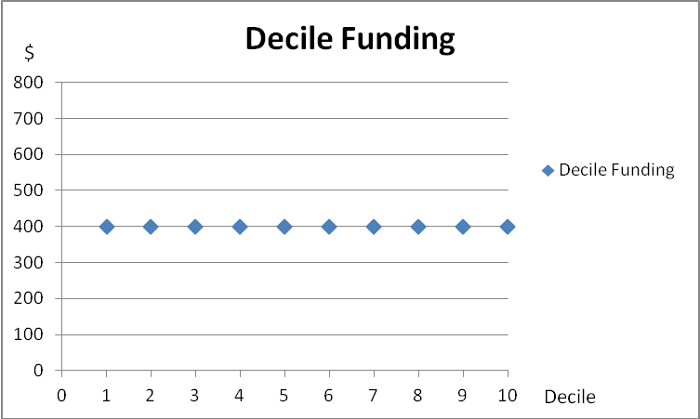

Perhaps this is where the “level playing field” idea comes from.
However, when we look at actual figures we get a very different picture, but I develop the graphs firstly by considering simply the decile related funding given in the Operations Grant

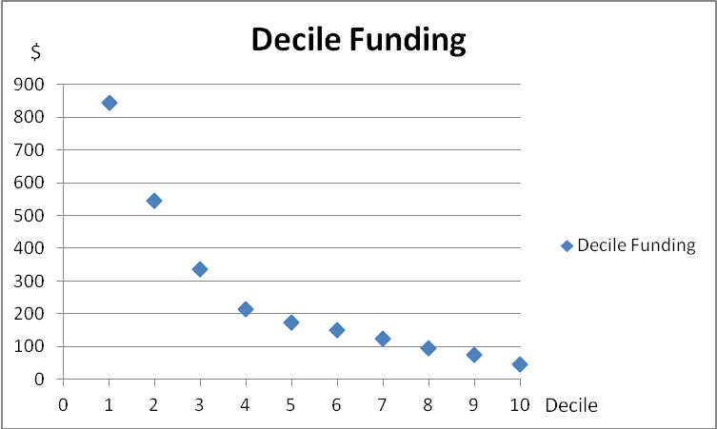

This graph is a mathematician’s delight being a power function of some sort and I wonder what the justification might be.

Now if we add all donations and fundraising we get this graph.

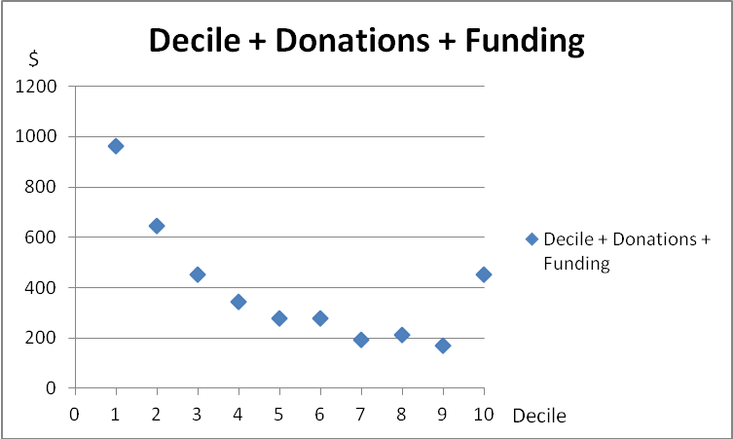

(NB. I was unable to collect the simple donation as there were inconsistencies in the treatment of trust income, some schools treating it as donation, some as fundraising.)

This seems to show changes to higher decile schools but not as much as I expected and the graph is indicating a type of bi-modal distribution rather than the flat line that would possibly be expected. However, this graph does suggest that my original supposition, that schools in the middle generally come out worse, might be right.

The next graph includes international students as another part of school generated funding.

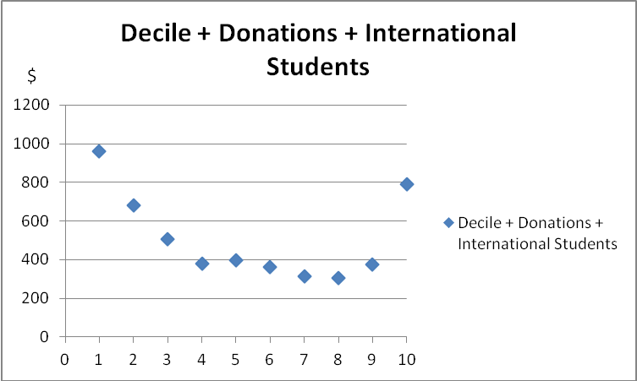

From this graph it can be seen that decile 5 to 9 begin to change their relative positions.
But it would seem those Colleges at the extremes are by far the better off, and that deciles 4 to 9 are similarly placed but much worse off than deciles 1, 2 and 10. And I must again say that my sample is likely to be unrepresentative with the exception of decile 2 schools, as the sample is small and geographically generally relatively closely located. I have included no South Island schools. I suspect, however, were the analysis done for all schools the pattern would be similar.

Whilst this might be considered the conclusion of my research I was stimulated by the data from PPTA paper “A level playing field” in 2012. I have included a table from this that summarises an analysis of data they collected which deals exclusively with donations and the information serves to suggest that there is again a correlation of decile with average donation and the following graph supports that.

Decile | Donations
1 | 53
2 | 92
3 | 101
4 | 104
5 | 112
6 | 121
7 | 197
8 | 233
9 | 379
10 | 423

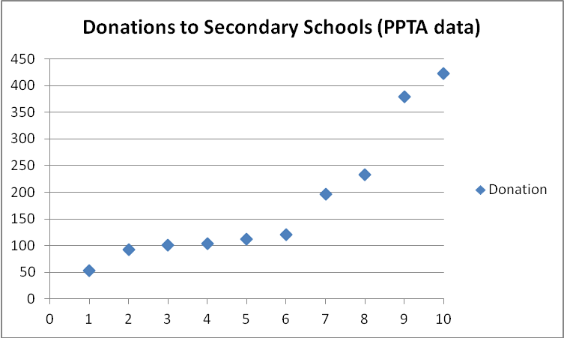

Taking this into account I wondered what effect a different rate of decile funding would have, so I used PPTA data and ‘regularised’ it with a straight line (another mathematicians delight) as is displayed below, using the figures for decile funding at decile 1 and decile 10 to produce a straight line.

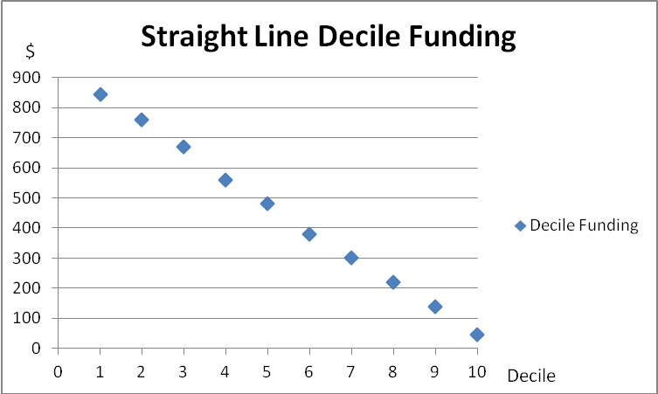

I then worked with the actual donations, fundraising and international students to create this table.

School | Decile | Straight Line Decile Funding | Decile + Donations + Fundraising + Int. Students
A | 10 | 46 | 654
B | 10 | 46 | 930
C | 9 | 140 | 350
D | 9 | 140 | 522
E | 8 | 220 | 536
F | 8 | 220 | 320
G | 7 | 300 | 395
H | 7 | 300 | 585
I | 6 | 380 | 585
J | 6 | 380 | 429
K | 5 | 480 | 798
L | 5 | 480 | 598
M | 4 | 560 | 730
N | 4 | 560 | 717
O | 3 | 670 | 812
P | 3 | 670 | 868
Q | 2 | 760 | 790
R | 2 | 760 | 789
S | 2 | 760 | 1037
T | 2 | 760 | 774
U | 2 | 760 | 803
V | 2 | 760 | 782
W | 2 | 760 | 833
X | 2 | 760 | 1292
Y | 2 | 760 | 776
Z | 2 | 760 | 898
AA | 1 | 845 | 979
BB | 1 | 845 | 945

Graphing it we get the following:

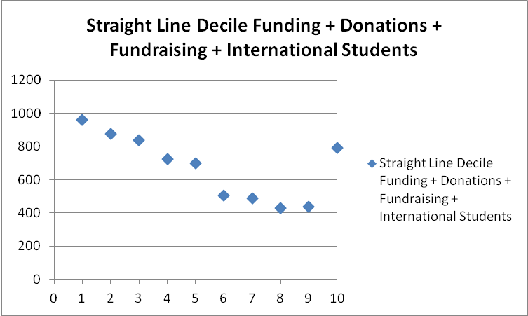

This seemed to produce a better, more equitable solution with a lesser range ($550) between highest and lowest.

I then dropped the top rate of decile funding by an arbitrary $150 and applied a new straight line to get some new data.

School | Decile | Straight Line Decile Funding | Decile + Donations + Fundraising + Int. Students
A | 10 | 46 | 654
B | 10 | 46 | 930
C | 9 | 120 | 330
D | 9 | 120 | 512
E | 8 | 190 | 511
F | 8 | 190 | 305
G | 7 | 260 | 375
H | 7 | 260 | 565
I | 6 | 330 | 560
J | 6 | 330 | 404
K | 5 | 420 | 768
L | 5 | 420 | 568
M | 4 | 500 | 730
N | 4 | 500 | 717
O | 3 | 560 | 812
P | 3 | 560 | 868
Q | 2 | 650 | 790
R | 2 | 650 | 789
S | 2 | 650 | 1037
T | 2 | 650 | 774
U | 2 | 650 | 803
V | 2 | 650 | 782
W | 2 | 650 | 833
X | 2 | 650 | 1292
Y | 2 | 650 | 776
Z | 2 | 650 | 898
AA | 1 | 700 | 979
BB | 1 | 700 | 945

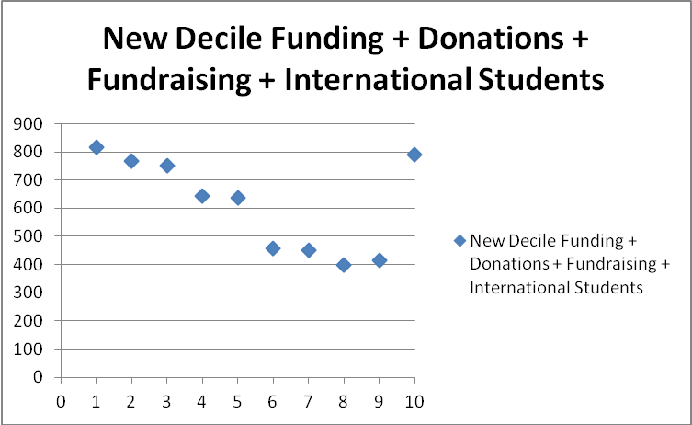

From this graph it can be seen that schools of deciles 6 to 9 are relatively distant from the other schools, and perhaps a step-wise function of $200 applied to the decile funding at these levels would level the paying (sic) field!

However, returning to the subject of my research, in summary for decile 1 to 3 schools the current decile related funding seems to satisfactorily remedy the ability of decile 10 schools to raise funds through their families and other sources. Whilst there may be “odd” figures for decile 8 and 9 schools, I believe these to be a factor of sample size and given time that could be easily established. It is my contention, however, that fund raising exploits are more common and successful in high decile schools, and not always attributed through ledgers to the areas of income I considered.

